

ADVERTISEMENT FOR PREQUALIFICATION

UCSF PRO-000002 HBW PROJECT #35003
July 2026

UCSF Health Helen Diller Hospital

Subject to conditions prescribed by Herrero Boldt Webcor (HBW), responses to the Prequalification Documents for a Best Value contract are sought from prospective Proposers for the following project:

Project Name: UCSF Health Helen Diller Hospital Project Number: 35003
Bid Package: BV.BP95-AFPQ - INC 5 - Firestopping

Jobsite Address: 501 Parnassus Avenue, San Francisco, CA 94143

PREQUALIFICATION OF PROSPECTIVE PROPOSERS
HBW has determined that Proposers who submit bids on this project must be prequalified.

Prequalification Package:
BV.BP95-AFPQ - INC 5 - Firestopping - Advertisement for Prequalification
Prequalified Proposers will be required to have at least one of the following California contractor's licenses:
- License Classification:
  - C-16 - FIRE PROTECTION CONTRACTOR
  - C-2 - INSULATION AND ACOUSTICAL

GENERAL DESCRIPTION OF WORK
UCSF Health is investing in a new hospital in pursuit of their mission to provide top-quality care to all patients and support research and education. The new hospital will be located at 501 Parnassus Avenue, San Francisco, CA 94143. HBW has been contracted for General Contracting for this project called UCSF Health Helen Diller Hospital (UCSF Health HDH, or HDH) and related Moffitt & Long Hospital renovations. The HDH project has multiple phases of procurement during the Preconstruction Services portion of the project.
UCSF Health's goal is to maximize innovation, quality, productivity, flexibility, and collaboration to create value for cost through use of the current, best-in-class project delivery model for large healthcare programs.
Constraints: The project site is constrained and within a densely built environment. Construction will take place immediately adjacent to and within existing acute care facilities, in close proximity to neighbors, and bordered by the Mount Sutro Preserve. The Contractor must coordinate with surrounding UC and non-UC projects with concurrent timelines.

The project will be delivered using an Integrated Form of Agreement (IFOA) project delivery model, incorporating lean project delivery process, tools, and behaviors. The project delivery team will be co-located in a “Big Room” for the duration of the project. UCSF and HBW have chosen to employ a Collaborative Design System strategy. The Trade Partner for BV.BP95-AFPQ - INC 5 - Firestopping - Advertisement for Prequalification will be working under a subcontract with HBW and will not be party to the IFOA.
All HDH scopes of work shall comply with Department of Health Care Access and Information (HCAI), formerly known as OSHPD, regulations and requirements, pursuant to California Building Standards Code.
The AFPQ#95 is to prequalify trades for BV.BP95 - INC 5 - Firestopping which will be published separately. BV.BP95 - INC 5 – Firestopping’s scope of work will include furnishing and installing of Firestopping. The qualified Proposer will be expected to provide an appropriate level of assistance with detailing and modeling in conjunction with the design team and trade partners requiring firestopping at their penetrations. This will include engaging with the Firestopping Manufacturers per the Specifications to identify appropriate products to be furnished and installed at penetrations, supporting in a Design-Assist capacity during the logistical planning of this scope and collaborating with the UCSF IFOA Team and its Proposer as required to complete this scope of work, and properly preparing to comply with and document all Inspections to mitigate the need for re-inspections or delaying the project schedule.
The Firestopping design is based on the use of Products from the following manufacturers: Hilti Inc., 3M, Specified Technologies, Inc., other identified in the 078400 Firestopping Specification.
The estimated construction cost for the bid package is $7,500,000.

TRADE PREQUALIFICATIONS INFORMATION & PROCESS
HBW seeks Trade Partners with significant experience in academic health care projects for public institutions and have determined that Proposers who plan to participate in this project must be prequalified by HBW in order to submit a bid.
To allow HBW to evaluate Proposers, each Proposer must submit a completed Prequalification Package before the Prequalification Deadline. If the prequalification is not submitted with all required qualifying information, the Proposer will be deemed not qualified and will not be allowed to submit a bid for this project.

Step 1: Submission of Prequalification Application on Trade Tapp
Proposers shall use the link stated in Section 4.1, part of this document, to submit the documents required for Prequalification through the BuildingConnected Trade Tapp online application on or before deadline stated under Section 4.1.
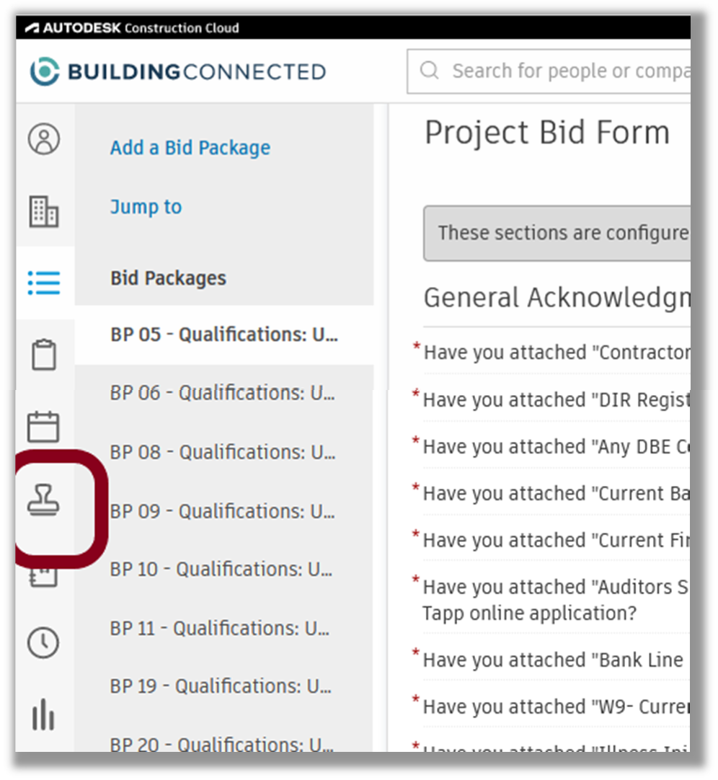
The information shall include general and specific experience, claim and surety history, financials, ability to meet schedule and budget requirements, experience in management and coordination, and requisite experience on projects of similar size, scope and complexity.
Documents required to be submitted are:

- Current Contractor’s License
- DIR Registration
- Disadvantage/Small Business Enterprise (DBE) Certificates, if applicable
- California Sellers Permit – if applicable


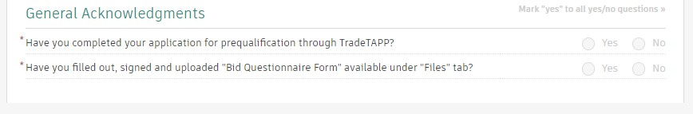
- Current Backlog/Work in Process (WIP) Breakdown
- Current Financial Statement
- Auditors Statement with last Audited/Compiled/Reviewed financial statement
- Current Bank Line of Credit Letter
- W9
- Injury Illness Prevention Plan and Code of Safe Practices
- Experience Modifier Rate (EMR) Letter
- OSHA 300 & 300 A Logs for last 3 years
- Insurance Certificate – General Liability, Auto, & Workers Comp
- Current Surety Capacity Letter with Bond Rates
Proposers must hold valid contractor licenses, be registered with the Department of Industrial Relations (DIR) and must provide the ability to obtain corporate surety (payment & performance) bonds, and insurance in order to be eligible for the Qualifications evaluation. This project is subject to the General Prevailing Wages, see https://www.dir.ca.gov/oprl/dprewagedetermination.htm.

Step 2: Prequalification Questionnaire Form

- Proposer must complete the “Prequalification Questionnaire Form” available on BuildingConnected in the “Files” tab.
- The completed “Prequalification Questionnaire Form” must be uploaded through the “Bid Form” tab on BuildingConnected before the “Advertisement for Prequalification” deadline stated below.

Step 3: Bid Form
- The “General Acknowledgements” Part of “Bid Forms” must be filled out by Proposer.

Evaluation Process:
Trade Contractors are evaluated based on all information submitted in steps 1, 2, and 3 above and those deemed prequalified to perform work will be invited to submit a bid for BV.BP95.

If the Proposer has previously completed a Proposer Prequalification through the HBW BuildingConnected Trade Tapp online application within the past 12 months, it does not need to resubmit and can skip Step 1 stated above; however, Proposer must complete Step 2 -BuildingConnected “Prequalification Questionnaire Form” & Step 3 – Bid Form before the Prequalification Deadline. Prequalification Questionnaire is to be provided by all proposers.

Only Prequalified Proposers will be allowed to submit bids for LS. BP95 – INC 5 - Firestopping

PREQUALIFICATIONS SCHEDULE & PROCEDURE

Package Publication Date & Location

Prequalification Package will be published on an electronic system called BuildingConnected by:
Wednesday, July 29, 2026, 12:00PM
Prequalification Documents will be available on BuildingConnected at the link below:
BV.BP95-AFPQ: INC 5 - Firestopping - Advertisement for Prequalification
Prospective proposers can log on to BuildingConnected and retrieve the Prequalification Questionnaire by project name and number.

If you have any questions regarding accessing the project and/or BuildingConnected, contact Natalie Watkins at nwatkins@webcor.com / (510) 219-6718 AND Chanelle Jones at cjones@webcor.com / (510) 604-9812.

The subject line of the email should state BuildingConnected Question and include Project Number/Name and Bid package Name/Number.

Deadline for Submission of Prequalification Documents

Submission of Prequalification Documents shall be through the Trade Tapp on BuildingConnected on or before:
Thursday, August 13, 2026, 5:00 PM
HBW reserves the right to request, receive, and evaluate supplemental information after the above time and date at its sole determination to finalize the prequalification process.

Revision to Prequalification Schedule: During the Prequalification process HBW may establish a new Proposal Deadline no earlier than 24 hours from

the prior Deadline, if no material changes are made to the prequalification criteria or Bid Form, and no earlier than 72 hours if material changes are made. In such event HBW will, at a minimum, notify applicants though the BuildingConnected of the revisions and new deadlines.

Announcement of Prequalification Outcome

Proposers will be notified of the prequalification status by:

Wednesday, August 26, 2026, 5:00PM
    - When the Bidding Documents become available, lump sum bids submitted directly to HBW and the University will be received ONLY from prequalified Contractors. Only proposers who have been prequalified by the University shall be invited to participate in a competitive bid for this project.
    - HBW reserves the right to reject any or all responses to Prequalification Questionnaires and to waive non-material irregularities in any response received.

Advertisement for BID Package BV.BP95– INC 5 - Firestopping

Bidding Documents will be publicly published within six (6) months of the announcement of the outcome of this Advertisement for Prequalification. Dates, times, and location set for receiving and opening of the bids will be set forth in the Advertisement for Bids.

OTHER IMPORTANT INFORMATION
Project Specific Insurance: Project will be insured under a University Controlled Insurance Program (UCIP) providing worker’s compensation and employer’s liability insurance coverage, commercial general liability insurance coverage, and excess liability insurance coverage for Work performed on or at the Project site (“UCIP Coverages”). All insurance policies required to be obtained by successful Proposer shall be subject to approval by University and HBW for form and substance. All such policies shall be issued by a company rated by Best as A- or better with a financial classification of VIII or better or have equivalent rating by Standard and Poor's or Moody's.

Public Work Requirements:
- Prevailing wage: The successful Proposer and its sub-tier Trade Partners will be required to follow the non-discrimination requirements set forth in the proposal documents and to pay prevailing wage rates as a minimum at the location of the work.

- Equal Opportunities: Every effort will be made to ensure that all persons have equal access to contracts and other business opportunities with the University within the limits imposed by law or University policy. Each Proposer may be required to show evidence of its equal employment opportunity policy. The successful Proposer and its trade partners will be required to follow the nondiscrimination requirements set forth in the Bidding Documents and to pay prevailing wage at the location of the work.
- California Labor Code The work described in the contract is a public work subject to section 1771 of the California Labor Code. No contractor or proposer, regardless of tier, may be listed on a Proposal for, or engage in the performance of any portion of this project unless registered with the Department of Industrial Relations pursuant to Labor Code section 1725.5 and 1771.1.

This project is subject to compliance monitoring and enforcement by the Department of Industrial Relations.

REGISTER AT THIS LINK:

https://www.dir.ca.gov/public-works/contractor-registration.html

PROTEST
If the prospective Proposer is determined by HBW not to be prequalified, the prospective Proposer may request a review by HBW and the University. Any such request must be received by HBW and the University within three (3) calendar days after receipt by the prospective Proposer of the determination. The decision resulting from such review is final and is not appealable within the University of California. Any person or entity not satisfied with the outcome of the prequalification must file a writ challenging the outcome within 10 calendar days from the date of the University's written notice regarding prequalification determination. Any assertion that the outcome of the prequalification process was improper will not be a ground for a bid protest. However, HBW reserves the right to accept late submissions and to request, receive, and evaluate supplemental information after the above time and date at its sole determination

Prequalification Protests must be emailed to UCSF Health at contract.services@ucsf.edu and HBW at bshambaugh@webcor.com, attention Bradley Shambaugh .
< END OF ADVERTISEMENT >

