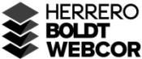

LS.36A – PAINTING AND WALL COVERING

Apparent Low Bidder Notification
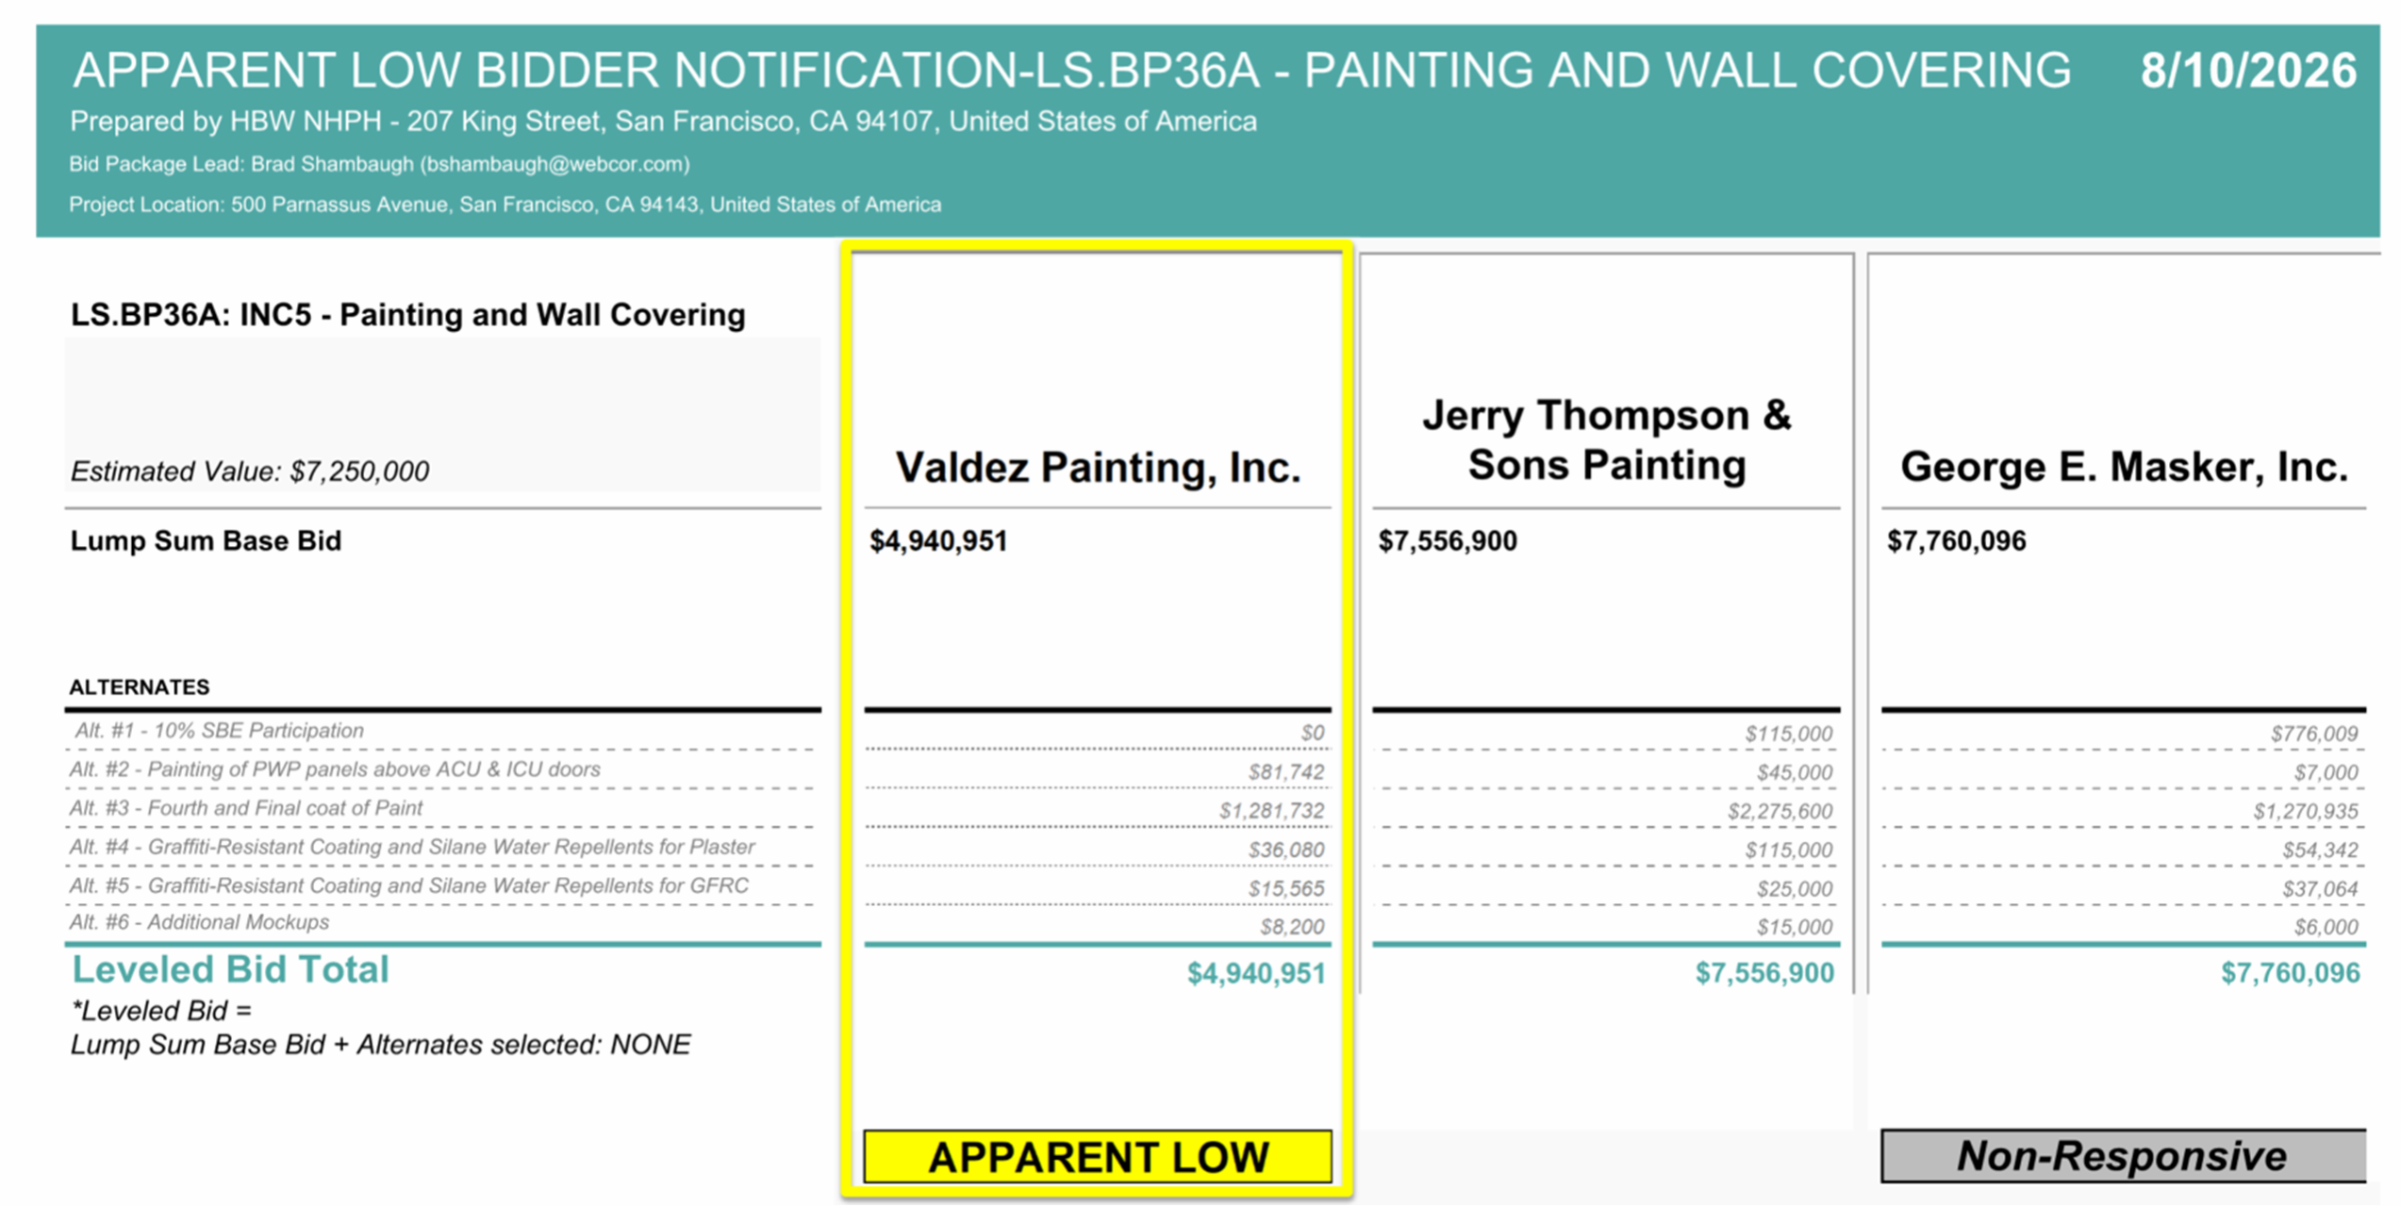
August 10, 2026

End of Apparent Low Bidder Notification

